

**Mobile Applications Development**

**Task-3**

**Course Instructor:** Muhammad Ahmed  **Total Marks: 10**

Student Name: Muhammad Haroon

Q1: Implement signup and sign in form without using any database with following properties:

1. First implement splash screen.
2. Second screen showing sign-up and sign-in button.
3. User press sign-up button and sign-up form shown.
4. After filling sign-up form user press sign-in button then next screen show that account is created.
5. Also used Toast.

**Solution:**

**First:**

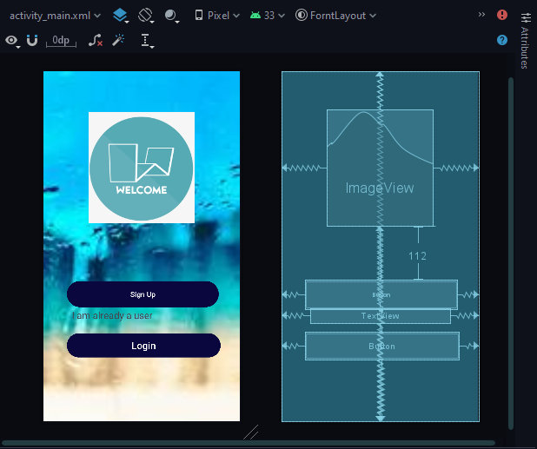

**Second:**

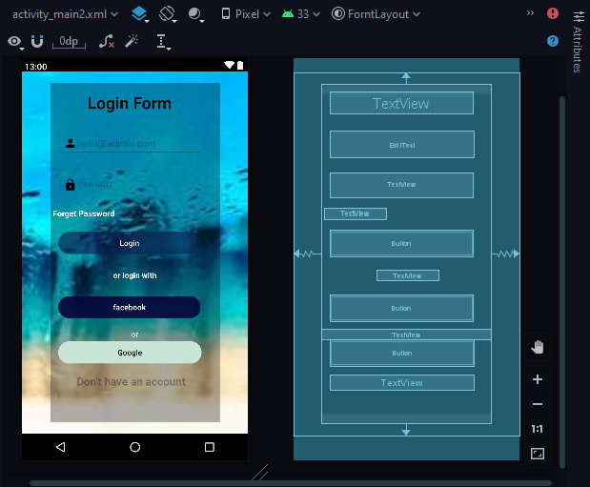

**Third:**

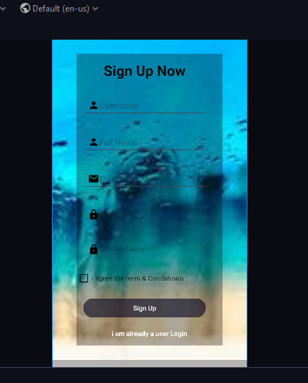

**XML Code:**

**First:**

<?*xml version*="1.0" *encoding*="utf-8"?>  
<androidx.constraintlayout.widget.ConstraintLayout *xmlns:android*="http://schemas.android.com/apk/res/android"  
 *xmlns:app*="http://schemas.android.com/apk/res-auto"  
 *xmlns:tools*="http://schemas.android.com/tools"  
 *android:id*="@+id/background"  
 *android:layout_width*="match_parent"  
 *android:layout_height*="match_parent"  
 *android:background*="@drawable/bg12"  
 *tools:context*=".MainActivity">  
  
 <ImageView  
 *android:id*="@+id/imageView"  
 *android:layout_width*="222dp"  
 *android:layout_height*="243dp"  
 *android:src*="@drawable/lg9"  
 *app:layout_constraintBottom_toBottomOf*="parent"  
 *app:layout_constraintEnd_toEndOf*="parent"  
 *app:layout_constraintHorizontal_bias*="0.497"  
 *app:layout_constraintStart_toStartOf*="parent"  
 *app:layout_constraintTop_toTopOf*="parent"  
 *app:layout_constraintVertical_bias*="0.163">  
  
 </ImageView>  
  
 <Button  
 *android:id*="@+id/button2"  
 *android:layout_width*="318dp"  
 *android:layout_height*="62dp"  
 *android:layout_marginTop*="112dp"  
 *android:backgroundTint*="#09073D"  
 *android:text*="Sign Up"  
 *android:textSize*="15dp"  
 *app:layout_constraintEnd_toEndOf*="parent"  
 *app:layout_constraintHorizontal_bias*="0.526"  
 *app:layout_constraintStart_toStartOf*="parent"  
 *app:layout_constraintTop_toBottomOf*="@+id/imageView">  
  
 </Button>  
  
 <TextView  
 *android:layout_width*="293dp"  
 *android:layout_height*="30dp"  
 *android:text*="I am already a user"  
 *android:textSize*="20dp"  
 *app:layout_constraintBottom_toBottomOf*="parent"  
 *app:layout_constraintEnd_toEndOf*="parent"  
 *app:layout_constraintStart_toStartOf*="parent"  
 *app:layout_constraintTop_toTopOf*="parent"  
 *app:layout_constraintVertical_bias*="0.708">  
  
 </TextView>  
  
 <Button  
 *android:id*="@+id/button3"  
 *android:layout_width*="322dp"  
 *android:layout_height*="58dp"  
 *android:layout_marginTop*="28dp"  
 *android:backgroundTint*="#09073D"  
 *android:text*="Login"  
 *android:textSize*="20dp"  
 *app:layout_constraintBottom_toBottomOf*="parent"  
 *app:layout_constraintEnd_toEndOf*="parent"  
 *app:layout_constraintHorizontal_bias*="0.55"  
 *app:layout_constraintStart_toStartOf*="parent"  
 *app:layout_constraintTop_toBottomOf*="@+id/button2"  
 *app:layout_constraintVertical_bias*="0.128">  
  
 </Button>

</androidx.constraintlayout.widget.ConstraintLayout>

**Second:**

<?*xml version*="1.0" *encoding*="utf-8"?>  
<androidx.constraintlayout.widget.ConstraintLayout *xmlns:android*="http://schemas.android.com/apk/res/android"  
 *xmlns:app*="http://schemas.android.com/apk/res-auto"  
 *xmlns:tools*="http://schemas.android.com/tools"  
 *android:id*="@+id/background"  
 *android:layout_width*="match_parent"  
 *android:layout_height*="match_parent"  
 *android:background*="@drawable/bg12"  
 *tools:context*=".MainActivity">  
  
 <LinearLayout  
 *android:layout_width*="309dp"  
 *android:layout_height*="616dp"  
 *android:background*="#50000000"  
 *android:orientation*="vertical"  
 *app:layout_constraintBottom_toBottomOf*="parent"  
 *app:layout_constraintEnd_toEndOf*="parent"  
 *app:layout_constraintStart_toStartOf*="parent"  
 *app:layout_constraintTop_toTopOf*="parent"  
 *app:layout_constraintVertical_bias*="0.495">  
  
 <TextView  
 *android:id*="@+id/editTextText"  
 *android:layout_width*="259dp"  
 *android:layout_height*="wrap_content"  
 *android:layout_margin*="15dp"  
 *android:ems*="10"  
 *android:text*="Login Form"  
 *android:gravity*="center"  
 *android:textColor*="#100E08"  
 *android:textSize*="30sp"  
 *android:textStyle*="bold"  
 *app:layout_constraintEnd_toEndOf*="parent"  
 *app:layout_constraintStart_toStartOf*="parent"  
 *tools:ignore*="TouchTargetSizeCheck" />  
  
 <EditText  
 *android:layout_width*="261dp"  
 *android:layout_height*="48dp"  
 *android:layout_margin*="15dp"  
 *android:drawableLeft*="@drawable/baseline_person_24"  
 *android:hint*="hello@admin.com"  
 *android:padding*="10dp">  
  
 </EditText>  
  
 <TextView  
 *android:layout_width*="259dp"  
 *android:layout_height*="wrap_content"  
 *android:layout_margin*="15dp"  
 *android:drawableLeft*="@drawable/baseline_lock_24"  
 *android:hint*=" Paswpord "  
 *android:padding*="10dp">  
  
 </TextView>  
  
 <TextView  
 *android:layout_width*="wrap_content"  
 *android:layout_height*="wrap_content"  
 *android:layout_margin*="5dp"  
 *android:text*="Forget Password"  
 *android:textColor*="@color/white"  
 *android:textSize*="15dp"  
 *android:textStyle*="bold"  
 *tools:ignore*="TextSizeCheck">  
  
 </TextView>  
  
 <Button  
 *android:layout_width*="259dp"  
 *android:layout_height*="wrap_content"  
 *android:layout_margin*="15dp"  
 *android:text*="Login"  
 *android:backgroundTint*="#6A0A1F54"  
 *android:textColorHighlight*="#FFFFFF"  
 *app:iconPadding*="8dp"  
 *app:rippleColor*="#82B1FF">  
  
 </Button>  
  
 <TextView  
 *textAlignment*="center"  
 *android:layout_width*="112dp"  
 *android:layout_height*="wrap_content"  
 *android:layout_gravity*="center_horizontal"  
 *android:layout_margin*="10dp"  
 *android:text*="or login with"  
 *android:textAlignment*="center"  
 *android:textColor*="@color/white"  
 *android:textStyle*="bold"  
 *tools:ignore*="MissingPrefix" />  
  
 <Button  
 *android:layout_width*="259dp"  
 *android:backgroundTint*="#B905083B"  
 *android:layout_height*="wrap_content"  
 *android:layout_margin*="15dp"  
 *android:text*="facebook">  
  
 </Button>  
  
 <TextView  
 *android:layout_width*="match_parent"  
 *android:layout_height*="wrap_content"  
 *android:layout_margin*="3dpdp"  
 *android:paddingHorizontal*="10dp"  
 *android:text*="or"  
 *android:textAlignment*="center"  
 *android:textColor*="@color/white">  
  
  
 </TextView>  
  
 <Button  
 *android:layout_width*="261dp"  
 *android:textColor*="@color/black"  
 *android:backgroundTint*="#C7E4D6"  
 *android:layout_height*="wrap_content"  
 *android:layout_marginHorizontal*="15dp"  
 *android:text*="Google">  
  
 </Button>  
  
 <TextView  
 *android:layout_width*="261dp"  
 *android:layout_height*="wrap_content"  
 *android:layout_margin*="15dp"  
 *android:gravity*="center_horizontal"  
 *android:hint*=" Don't have an account"  
 *android:textAlignment*="center"  
 *android:textColor*="#096D56"  
 *android:textSize*="20dp"  
 *android:textStyle*="bold" />  
  
  
 </LinearLayout>  
  
  
</androidx.constraintlayout.widget.ConstraintLayout>

**Third:**

<?*xml version*="1.0" *encoding*="utf-8"?>  
<androidx.constraintlayout.widget.ConstraintLayout *xmlns:android*="http://schemas.android.com/apk/res/android"  
 *xmlns:app*="http://schemas.android.com/apk/res-auto"  
 *xmlns:tools*="http://schemas.android.com/tools"  
 *android:id*="@+id/background"  
 *android:layout_width*="match_parent"  
 *android:layout_height*="match_parent"  
 *android:background*="@drawable/bg12"  
 *tools:context*=".MainActivity">  
  
 <LinearLayout  
 *android:layout_width*="309dp"  
 *android:layout_height*="616dp"  
 *android:background*="#50000000"  
 *android:orientation*="vertical"  
 *app:layout_constraintBottom_toBottomOf*="parent"  
 *app:layout_constraintEnd_toEndOf*="parent"  
 *app:layout_constraintStart_toStartOf*="parent"  
 *app:layout_constraintTop_toTopOf*="parent"  
 *app:layout_constraintVertical_bias*="0.495">  
  
 <TextView  
 *android:id*="@+id/editTextText"  
 *android:layout_width*="259dp"  
 *android:layout_height*="wrap_content"  
 *android:layout_margin*="15dp"  
 *android:ems*="10"  
 *android:text*="Sign Up Now"  
 *android:textAlignment*="center"  
 *android:textColor*="#100E08"  
 *android:textSize*="30sp"  
 *android:textStyle*="bold"  
 *app:layout_constraintEnd_toEndOf*="parent"  
 *app:layout_constraintStart_toStartOf*="parent"  
 *tools:ignore*="TouchTargetSizeCheck" />  
  
 <EditText  
 *android:layout_width*="261dp"  
 *android:layout_height*="48dp"  
 *android:layout_margin*="15dp"  
 *android:drawableLeft*="@drawable/baseline_person_24"  
 *android:hint*="Username"  
 *android:padding*="10dp">  
  
 </EditText>  
 <EditText  
 *android:layout_width*="261dp"  
 *android:layout_height*="48dp"  
 *android:layout_margin*="15dp"  
 *android:drawableLeft*="@drawable/baseline_person_24"  
 *android:hint*="Full Name"  
 *android:padding*="10dp">  
  
 </EditText>  
 <EditText  
 *android:layout_width*="261dp"  
 *android:layout_height*="48dp"  
 *android:layout_margin*="15dp"  
 *android:drawableLeft*="@drawable/baseline_email_24"  
 *android:hint*="Enter Your Mail"  
 *android:padding*="10dp">  
  
 </EditText>  
  
 <TextView  
 *android:layout_width*="259dp"  
 *android:layout_height*="wrap_content"  
 *android:layout_margin*="15dp"  
 *android:drawableLeft*="@drawable/baseline_lock_24"  
 *android:hint*=" Paswpord "  
 *android:padding*="10dp">  
  
 </TextView>  
  
 <TextView  
 *android:layout_width*="259dp"  
 *android:layout_height*="wrap_content"  
 *android:layout_margin*="15dp"  
 *android:drawableLeft*="@drawable/baseline_lock_24"  
 *android:hint*=" Confirm Paswpord "  
 *android:padding*="10dp">  
  
 </TextView>  
 <CheckBox  
 *android:id*="@+id/checkBox"  
 *android:layout_width*="match_parent"  
 *android:layout_height*="wrap_content"  
 *android:text*="I agree the term & Condation's" />  
  
 <Button  
 *android:layout_width*="259dp"  
 *android:layout_height*="wrap_content"  
 *android:layout_margin*="15dp"  
 *android:text*="Sign Up"  
 *android:backgroundTint*="#63060922"  
 *app:iconPadding*="8dp"  
 *app:rippleColor*="#82B1FF">  
  
 </Button>  
  
 <TextView  
 *textAlignment*="center"  
 *android:layout_width*="208dp"  
 *android:layout_height*="wrap_content"  
 *android:layout_gravity*="center_horizontal"  
 *android:layout_margin*="5dp"  
 *android:text*="i am already a user Login"  
 *android:textAlignment*="center"  
 *android:textColor*="@color/white"  
 *android:textStyle*="bold"  
 *tools:ignore*="MissingPrefix" />  
  
  
  
  
  
 </LinearLayout>  
  
  
</androidx.constraintlayout.widget.ConstraintLayout>

,,,,,,,,,,,,,,,,,,,,,,,,,,,,,The End,,,,,,,,,,,,,,,,,,,,,,,,,,,,,,,,